**DB 6360 Project Phase II – EER to Relation Mapping**

**EER Modification:**

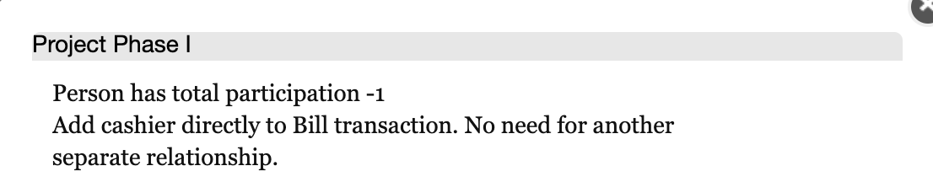

Modified EER Diagram is appended. All EER diagram assumptions remain the same and was described in project phase I document.

**Relations used in mapping:**

Person, Phone Number, Employee, Silver Customer, Gold Customer, Membership Card, Online Order, Online Order Detail, Product, Supplier, Aisle, Product-Aisle Assignment, Store, Shift Duty, Bill Transaction, Purchase Detail, Sale, Voucher, Promotional Discount, Voucher Bought Record.

**Mapping Algorithm:**

1. Mapping Strong Entity types by creating relations directly, includes all the simple attributes, and the simple component attributes of a composite attribute.
2. Mapping multiple value attributes, e.g. Phone Number, by creating a new relation with Person ID as its foreign key point to Person.
3. Mapping Weak Entity types by creating relations, adding its owner’s primary key as its foreign key point to its owner. Its primary key is the combination of its owner’s primary key and its partial key.
4. Mapping 1:N relationship by adding a forging key in N side point to 1 side. For My EER diagram there’s no M:N relationship so don’t need to consider about that situation.
5. Mapping Specialization or Generalization, it used some different methods:
6. Person (Superclass) to Employee(subclass) and Silver Customer(subclass), add the Person’s primary key in its subclasses.
7. Employee (Superclass) to Manager (subclass), Cashier (subclass), Floor Staff (subclass). Combine them into one Employee relation, with employee type to identify its subclasses.
8. Silver Customer (superclass) to Non-online Customer (subclass), Online Customer (subclass). Combine them into one Silver Customer relation, with two flags to identify its subclasses.
9. Product (superclass) to Perishable (subclass), non-perishable (subclass). Combine them into one Product relation, with one bool attribute “Is Perishable” to identify its subclasses.
10. Mapping Union Types. Employee (superclass), Non-Online Customer (superclass) to Gold Customer (subclass). Add Gold Customer’s primary key into its superclass as the foreign key point to it.